# Efolio Week 11-12

Zehui Zhang

34103600

# Week 11

# EFOLIO TASK 11.1

**The link to the deployed project:**

[fit5032-efolio-9ix.pages.dev](https://fit5032-efolio-9ix.pages.dev/)

**Corresponding screenshot:**

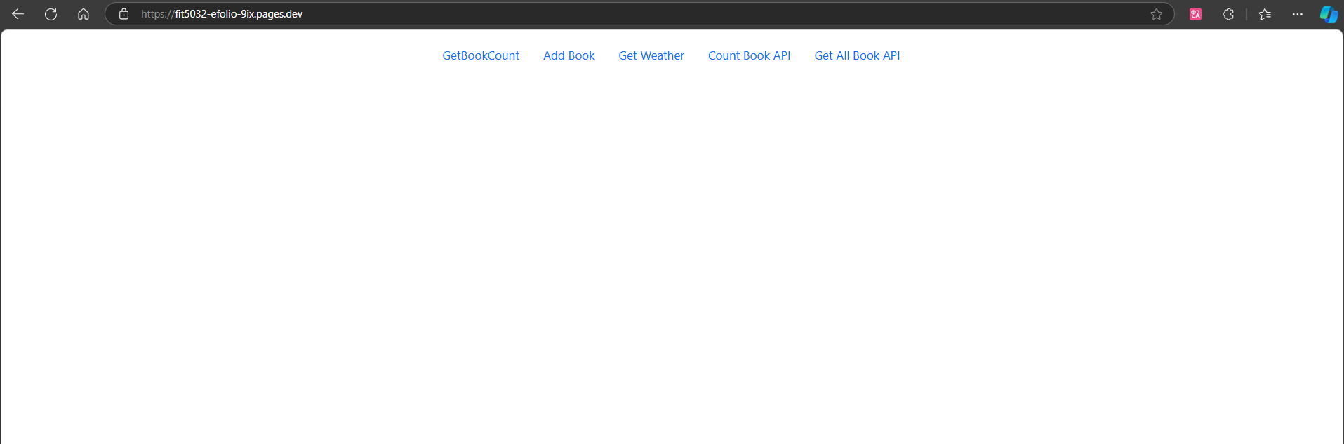

**Screenshot of Cloudflare page:**

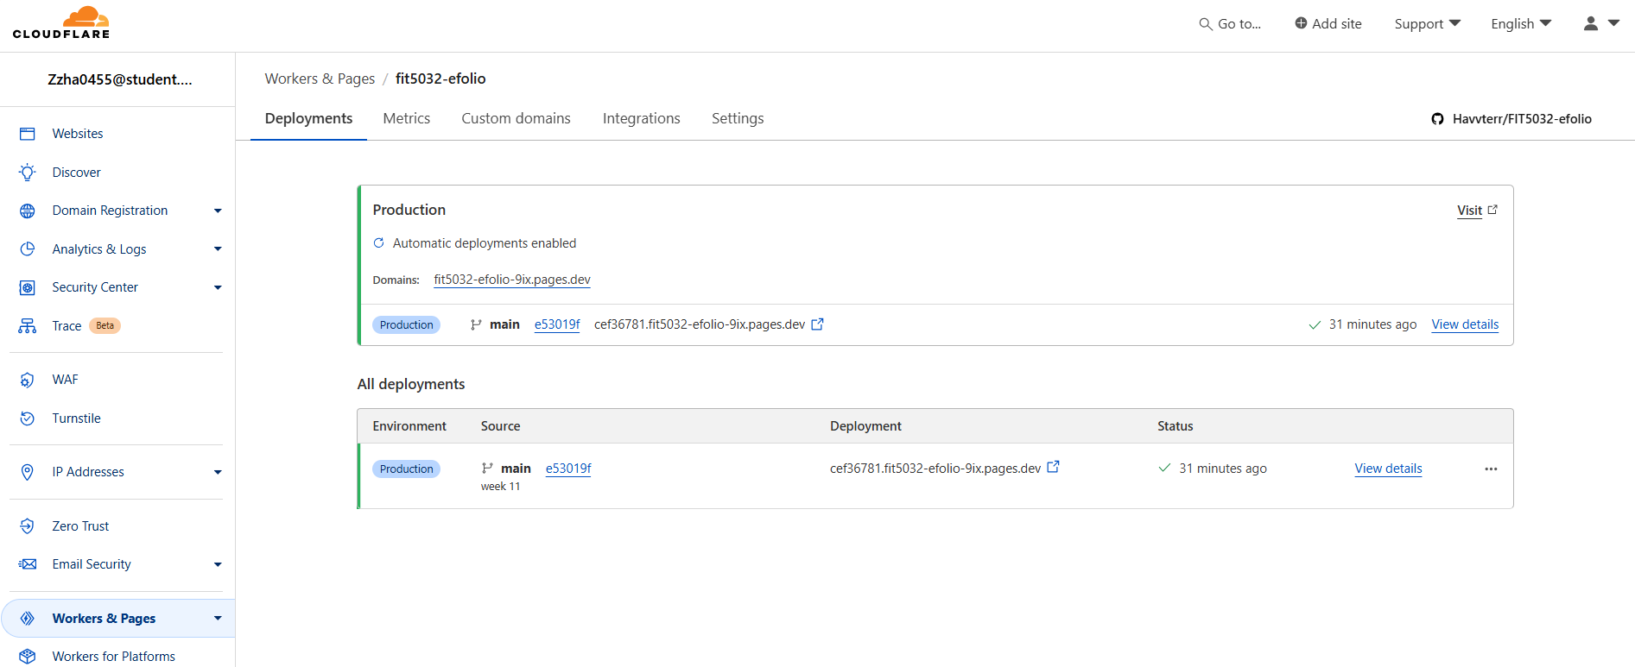

# EFOLIO TASK 11.2